Project Design Phase-II
Data Flow Diagrams & User Stories
Date | Team ID | Project Name | Maximum Marks
10 october 2026 |  | Car Rental Request Automation | 4 Marks

Data Flow Diagrams
A Data Flow Diagram (DFD) is a visual representation of the information flows within a system. It shows how data enters and leaves the system, what changes the information, and where data is stored.

DFD Level 0 / Level 1 – Car Rental Request Automation
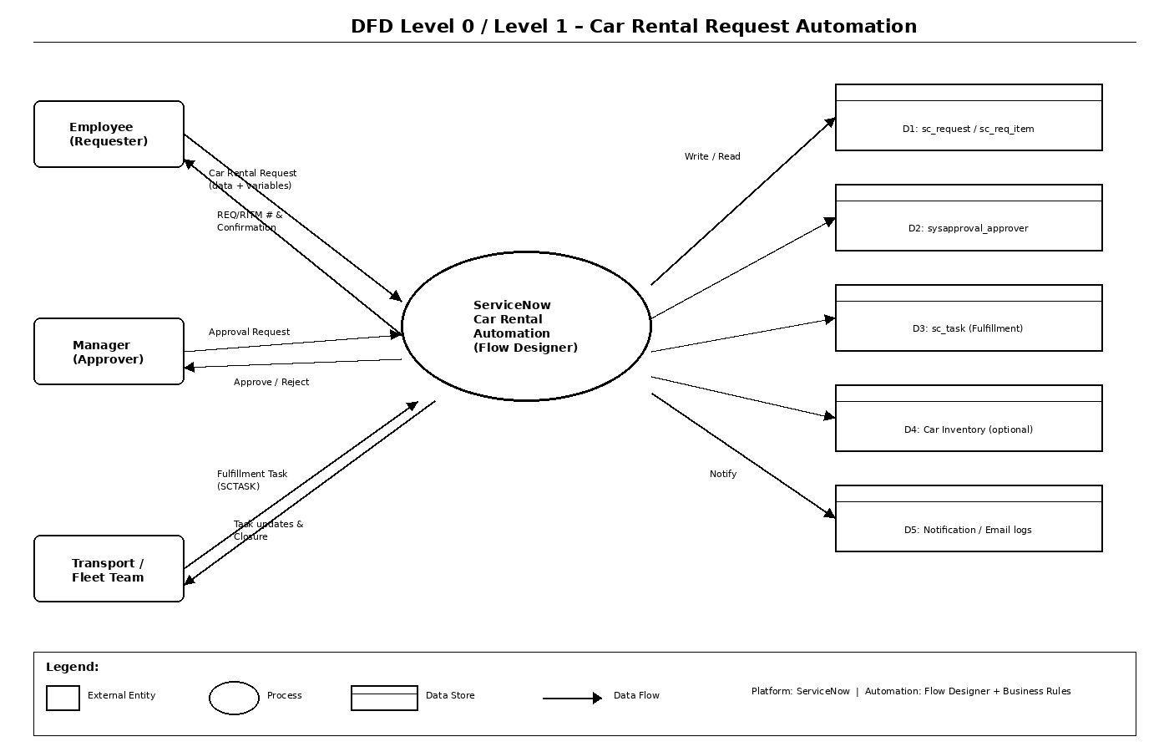
External Entities & Major Data Flows:
- Employee (Requester) → submits Car Rental Request data (dates, locations, car type, reason)
- Manager → receives Approval Request; returns Approve / Reject decision
- Transport / Fleet Team → receives Fulfillment Task; updates car assignment & task status
- ServiceNow Platform (Central Process) → creates REQ / RITM / SCTASK / Approval records; sends notifications
- Notification Engine → email / portal messages to all parties
Core Data Stores:
- D1: sc_request / sc_req_item (REQ & RITM) – request header and item details
- D2: sysapproval_approver – approval records and decisions
- D3: sc_task – fulfillment tasks for Transport team
- D4: Custom Car Inventory table (optional) – available vehicles, status, assignment history
- D5: sys_email / notification logs – communication history

DFD Level 1 – Major Processes
- P1 – Submit Catalog Request: Employee fills variables → creates REQ + RITM
- P2 – Route for Approval: Flow Designer creates Approval record → Manager decision
- P3 – Create Fulfillment Task: On approval → SCTASK assigned to Transport group
- P4 – Fulfill & Close: Transport updates task → RITM / REQ closed; notifications sent
- P5 – Notify Stakeholders: Triggered at each state change (submission, approval, rejection, closure)

User Stories
User stories for the Car Rental Request Automation product.
User Type | Epic | USN | User Story / Task | Acceptance Criteria | Priority | Release
Employee | Catalog Request | USN-1 | As an employee, I can open the Service Catalog item “Car Rental Request” and submit a request with date, locations, duration, car type and reason. | REQ & RITM created; confirmation number shown. | High | Sprint-1
 |  | USN-2 | As an employee, I receive an email / portal notification confirming my car rental request submission. | Notification received with request number and summary. | High | Sprint-1
 | Status Tracking | USN-3 | As an employee, I can view the current status of my car rental request from My Requests / Service Portal. | Status and activity stream visible and up-to-date. | High | Sprint-1
 |  | USN-4 | As an employee, I receive a notification when my request is approved, rejected or completed. | Correct notification with reason (if rejected) or next steps. | High | Sprint-1
Manager | Approval | USN-5 | As a manager, I receive a notification and can approve or reject a car rental request assigned to me with optional comments. | Approval record updated; request advances or is cancelled. | High | Sprint-1
 |  | USN-6 | As a manager, I can see key request details (dates, locations, car type, reason) on the approval form. | All relevant variables displayed on approval UI. | Medium | Sprint-1
Transport Team | Fulfillment | USN-7 | As a Transport team member, I receive an automatic SCTASK when a car rental request is approved. | Task appears in group queue with correct assignment and variables. | High | Sprint-1
 |  | USN-8 | As a Transport team member, I can update the task (assign car, add work notes) and close it, which closes the parent request. | Task closure updates RITM/REQ state; requester notified. | High | Sprint-1
Admin | Config & Reporting | USN-9 | As an admin, I can capture all configuration changes in an Update Set for promotion. | Update Set contains all relevant records and can be committed on target instance. | High | Sprint-1
 |  | USN-10 | As an admin, I can view reports / dashboards showing open car rental requests, cycle times and SLA performance. | Reports filterable by department, car type, status; data accurate. | Medium | Sprint-2

Note: All user stories map to Flow Designer stages, Business Rules and Catalog configuration. Implementation follows ServiceNow best practices (Update Sets, ACLs, Flow error handling).

